Analysis of Netflix
Name:
Tutor:
Institution:

Introduction
Netflix is a DVD rental service that is subscribed online. It was founded by Red Hasting and Marc Randolph in 1997. It has more than 6.7 million subscribers from all over the world (Walker et. al, 2017). Netflix was among the first group to start up an online and still remain popular. The company provides prepaid services for customers who have subscribed to unlimited rental monthly. Netflix provides streaming videos on the internet upon demand.it has become one of the largest online product and service providers in the U.S. it leads over its Wal-Mart and Blockbuster who are its main competitors (Cardy & Selvarajan, 2006).Since its invention of online movie rental, the company has grown is reputation and growing at a significant rate.
In 2010, the number of subscribers to Netflix increased by 52 percent, taking 2009 as the base year. Netflix is however challenged by other online products and service providers such as Amazon, Redbox, Flixter, Hulu, Apple and Google (Abraham, 2013). Netflix uses 35 warehouses based in the United States to conduct its operations. Since it was initiated, the company has tried to improve its reputation by improving their services as technology changes. The use of technology in providing quality and improved services to its customers has highly attributed to the increase in profits and success in general. This paper examines the SWOT analysis of Netflix where the company will be examined from its strengths, weakness, opportunities, and threats.
Netflix does not just provide online movies but also provides agricultural goods to the citizens of America and offers all subscribe access to films, movies, and television. Moreover, Netflix re-invented a new model of home video rental and have employed a very innovative team to provide customer services. For Netflix to lead and able to have a strong reputation, it keeps innovating to increase its customer base.
Core services
The subscribers to Netflix gain access to watch movies instantly by streaming Netflix ensures it keeps on updating its movies as soon as it is released. It is through Netflix that most people learn about a released movie. The television shows and movie shows are now accessible through mobile devices and over televisions through the internet. In the U.S, all subscribers have a privilege of receiving a DVD with standard definition as well as getting Blu-ray which is delivered to someone’s place (Cardy & Selvarajan, 2006).
Netflix markets itself and its products through various platforms such as televisions, radio, broad-based media and online advertising. This strategy targets the right consumers of Netflix since most of the times, as much as everyone has a smartphone, only those who spend time on the internet is likely to get as many advertisements as possible. This age group contains the youths who are movie lovers in their own different tastes and preferences. This is likely to get to so many potential customers of Netflix.

STRENGTHS
Netflix maintains a close relationship with the studios for it serves as the source of its wealth. It also has a wide and deep library. It has offered more than 25,000 films that are ever published on the DVD. It has spread out over 12 million disks to its subscribers with each bearing a number of copies. Netflix also contains a recognizable hand. It is considered to be the largest company in the world to provide online rental services to subscribers, it has enriched its brand which translates into a very strong reputation.
Netflix has its expertise in logistics. For its services since 1998, Netflix has a good database of all its operations and through internal work cooperation, it continues to develop even more advance logistical software. Netflix is the widest delivery network known by everyone. It has over 30 distributing centers and serves every customer upon request with delaying. Moreover, Netflix is known to utilize a recommendation strategy that is technology based. Through customer’s rating and increased views, Netflix is able to recommend other related products to the customer. The more ratings there are for a film, the more it is likely to be recommended to its viewers and thus, Netflix increases its sales.
They have a high client acquisition momentum. Each day, Netflix continues to increase its subscribers more than there are to unsubscribe. Netflix holds over 2 million number of subscribers. This number is projected to increase in the next 2-5 years. Additionally, Netflix wins many people’s favor, for proving a very low price on each film. In turn, this increases the turnover of Netflix. According to Gabrielli (2017), Netflix provides film titles at $1.50 to $1.75 per DVD. The services are also offered in packages allowing the subscribers to pay a monthly subscription of $17.95. at a package subscription, cost of a film per DVD is less. This strategy encourages customers to go for the monthly package which increases the revenue of Netflix.
Netflix uses an improved strategy to make sure the customer is comfortable and well served. It ensures there no other hidden charges such as late fees or monthly maintenance fee. This flat monthly fee was founded by Netflix. Most the companies have adopted this strategy and most especially the competitors of Netflix.
Netflix is a brand and sometimes people choose its services over the services from other competing companies for its name. In more than 10 years now, Netflix has been known to be a reliable and trustworthy online rental film provider (McManus & Botten, 2006). Various people join the company entirely for its name without finding out if there are other people in the company proving the services in better terms than Netflix most especially if they have no time of researching (Smith & Sharif, 2007).
Netflix has survived during all economic cycles due to its customer base compared to other competing companies i.e. the higher the number of subscribers, the greater the revenue. This increases the bargaining power of Netflix over any other company. By having more than 100 million subscribers, every studio would cooperate to secure its content. This customer base is one of its strongest strengths. The diagram below shows the growth of Netflix providers from 2007 to 2017.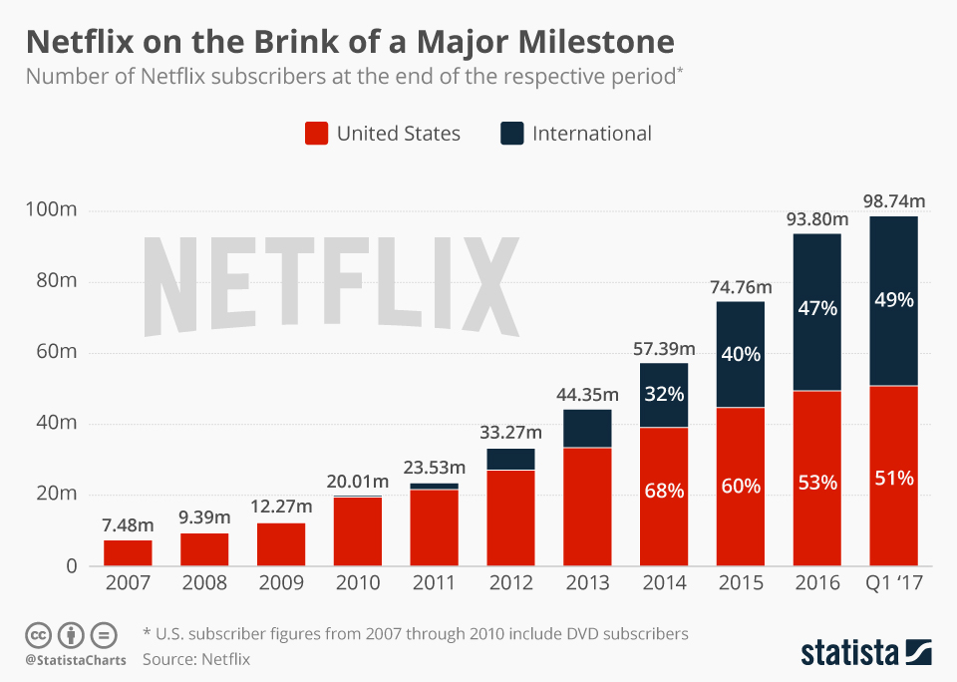

Netflix focuses on providing original content to win customer loyalty for its customers. It ensures it secures all original shows for people to depend on its services. In 2017, Netflix used this strategy and it increased its subscribers from around 80 million to more than 100 million subscribers (Smith & Sharif, 2007). The house of cards was the game changer to then especially since all the episodes to the first season was released all at ones. This show attracted a lot of customers. The company continues to enjoy in abundance the increase in customer base by including shows for kids, stand up comedies and documentaries in their library.

WEAKNESSES
Netflix depends on a very strong supplier. Its main inputs are from very few suppliers who are strong enough to shake Netflix. Most films come from Hollywood providers and are usually handled and managed by only one service providers-USPS. All the services and payments are made online to this supplier which the credit card is processed by four big credit card companies. The problem in having one sole supplier is that the supplier may fail Netflix or even take advantage and Netflix would be left vulnerable with no other supplier to depend on.
There is volatility in performance. In providing Netflix performance, it depends on some variables which are listed in the annual report. In demand for a product (film), the variable has to be considered. The variable involved in this case could be a recommendation, tastes, and preferences of a consumer (Cardy & Selvarajan, 2006).

OPPORTUNITIES
In Netflix, the team focuses on digital delivery. Netflix takes advantage of their technological advancement which detects what the consumer loves and enjoys watching then sends some films as a recommendation. This is a very rare strategy in the film industry. Being that only Netflix holds this expertise, it gets an opportunity of acquiring customer loyalty and increased customer base.
Another opportunity that Netflix holds, it’s the use of DVD format which has been a dominant strategy over more than 110 years. Even today, people still use DVD to watch films. The DVD format strategy is not likely to end soon. According to Bradshaw (2017), Netflix is seen to take lead in utilizing them in the film industry. From the financial position of Netflix, it is found to operate on net free basis. This increases their potential to borrow and increase its networking base and expand. When a company is in a lot of debts, it holds a very small possibility of being granted a loan. For it is believed that the more loans a company is found in, the higher the possibility of defaulting.
From the balance sheet of a 5-year trend, the total assets of the company are seen to increase significantly from 2014 to 2018. In 2014, the total assets were said to be 7.06 billion dollars which increased to 10.2 billion dollars in 2015, increased again in 2016 to 13.59 billion dollars. It then boomed to 25.97 billion dollars in 2018. The financial statement also indicates that in this five-year trend, Netflix has not had any shot term debts, income tax payable, dividends payable and accrued payroll. Netflix has increased its revenues/sales over the five years. In 2015, revenues increased from 5.5 billion dollars to 6.68 billion dollars. It then increased significantly in 2017 to 11.69 billion dollars. In 2018, it booms to 15.76 billion dollars (Fund, 2013). With this trend, Netflix is projected to increase along the years
Annual Financials for Netflix Inc
Fiscal year is January-December. All values USD millions. | 2014 | 2015 | 2016 | 2017 | 2018
Sales/Revenue | 5.5B | 6.78B | 8.83B | 11.69B | 15.79B
Cost of Goods Sold (COGS) incl. D&A | 3.75B | 4.59B | 6.03B | 7.66B | 9.97B
COGS excluding D&A | 970.96M | 1.04B | 1.1B | 1.33B | 2.31B
Depreciation & Amortization Expense | 2.78B | 3.55B | 4.92B | 6.33B | 7.66B
Depreciation | - | - | - | - | -
Amortization of Intangibles | - | - | - | - | -
Gross Income | 1.75B | 2.19B | 2.8B | 4.03B | 5.83B

As Netflix only relies on one major supplier in providing their inputs, the prices of these inputs become a threat. Netflix has a tendency of being exposed to unstable periods due to the changing policies of its supplier and in most cases, due to fluctuations in price. According to Mayfield (2000), when the price of inputs for any commodity is increased, in return, the supplier shifts the burden to the consumer by increasing the prices of these consumers good. However, a producer is careful not to scare away its customers over a short period of the fluctuation. The USPS increases the cost of processing the credit card which dramatically impacts the Netflix economy negatively.

It is possible for the studio to form an alliance with another bigger player in this online film renting industry such as Wal-Mart and Blockbuster, especially if in times they appear to be advantageous (Cardy & Selvarajan, 2006). This act would worsen the competitive advantage that Netflix holds over other competing players. Additionally, studios may refuse to renegotiate with Netflix in the revenue sharing policy. It is likely to change in most times especially due to the influence of the suppliers.
In return, for Netflix to have a fair share, they are then required to renegotiate with the studio to not face the pinch of price increment alone. This action may not necessarily leave the economy of Netflix worse off, but it will definitely increase the working capital of Netflix (Hayton & Kelley, 2006). To some point, to keep the business operations going, the working in the capital ratio is sometimes financed as a debt especially with a short time period at hand.
From advancement in technology, there have been other channels of providing entertainment to customers where some of them are free others are too cheap (Carroll, Menenberg & Kwok, 2009). Digitalization of televisions and other new technological solutions has enabled easy access to these entertaining channels such as youtube, video over IP, pay per view, VOD. Additionally, people have found other ways of entertaining themselves during their leisure time which includes listening to music and playing video games (Smith & Sharif, 2007). Being that watching movies online are not the only way to entertain them, Netflix is like to reduce its sales as time changes.
Another threat is the fact that the industry of film provide is open to new entrants into the market. The rental market is already competitive with the number of suppliers it contains so far. With other people joining this industry, issues of copycat by small invading companies are likely to occur. The new entrants fluctuate the price of providing rental films for customers as there will be a lot of firms to put into consideration when setting the price. Usually, this is not good for the market.
Another big factor that contributes to a threatening factor is the management growth of Netflix. According to Mayfield (2000) when companies experience growth, they tend to focus on celebrating that they forget the competitors are busy working. Netflix has had a history of success and big success over many years of time. The team may focus on success too much and get reluctant on working. If the company doesn’t practice successful management, the company may suffer.

Conclusion

From the above analysis, Netflix seem s to embrace more strengths and opportunities than the weaknesses and threats available. Netflix is a poised company admired and trusted by many. It has grown significantly over the years is projected to grow even in the future. The assessment of Netflix describes the importance of embracing technology and using it to the advantage of the business. According to the financial assessment, Netflix is a buy in the future as it continues to increase its network base and growing with the advancement in technology.

References
Bradshaw, T. (2017) Netflix boosted as viewers outside the US tune in. Financial Times.
Bradshaw, T., & Bond, S. (2017). Netflix looks to become world's entertainer as it hits milestone. Financial Times.
Cardy, R. L., & Selvarajan, T. T. (2006). Competencies: Alternative frameworks for competitive advantage. Business Horizons, 49(3), 235-245.
Fund, B. N. B. B. (2013). Annual Financial Statements. Energy, 22(55,105,067), 58-504.
Gabrielli, G. (2017). Netflix inc. valuation (Doctoral dissertation).
Hayton, J. C., & Kelley, D. J. (2006). A competency‐based framework for promoting corporate entrepreneurship. Human Resource Management: Published in Cooperation with the School of Business Administration, The University of Michigan and in alliance with the Society of Human Resources Management, 45(3), 407-427
Mayfield, E. S. (2000). Netflix. com, Inc. Harvard Business School Pub..
McManus, J., & Botten, N. (2006). Competitive analysis: Thinking beyond stage one. Management Services, 50(2), 10-15.
Smith, R., & Sharif, N. (2007). Understanding and acquiring technology assets for global competition. Technovation, 27(11), 643-649.
Walker, R., Jeffery, M., So, L., Sriram, S., Nathanson, J., Ferreira, J., ... & Merkley, G. (2017). Netflix leading with data: The emergence of data-driven video. Kellogg School of Management Cases, 1-19.
Abraham, S. (2013). Will business model innovation replace strategic analysis?. Strategy & Leadership, 41(2), 31-38.
Carroll, H., Menenberg, A., & Kwok, I. (2009). Strategic Report for Netflix, Inc. Hentet fra http://economics-files. pomona. edu/jlikens/SeniorSeminars/oasis/reports/-NFLX. pdf. Sist avlest, 21, 17.

